**FICB Work Map**

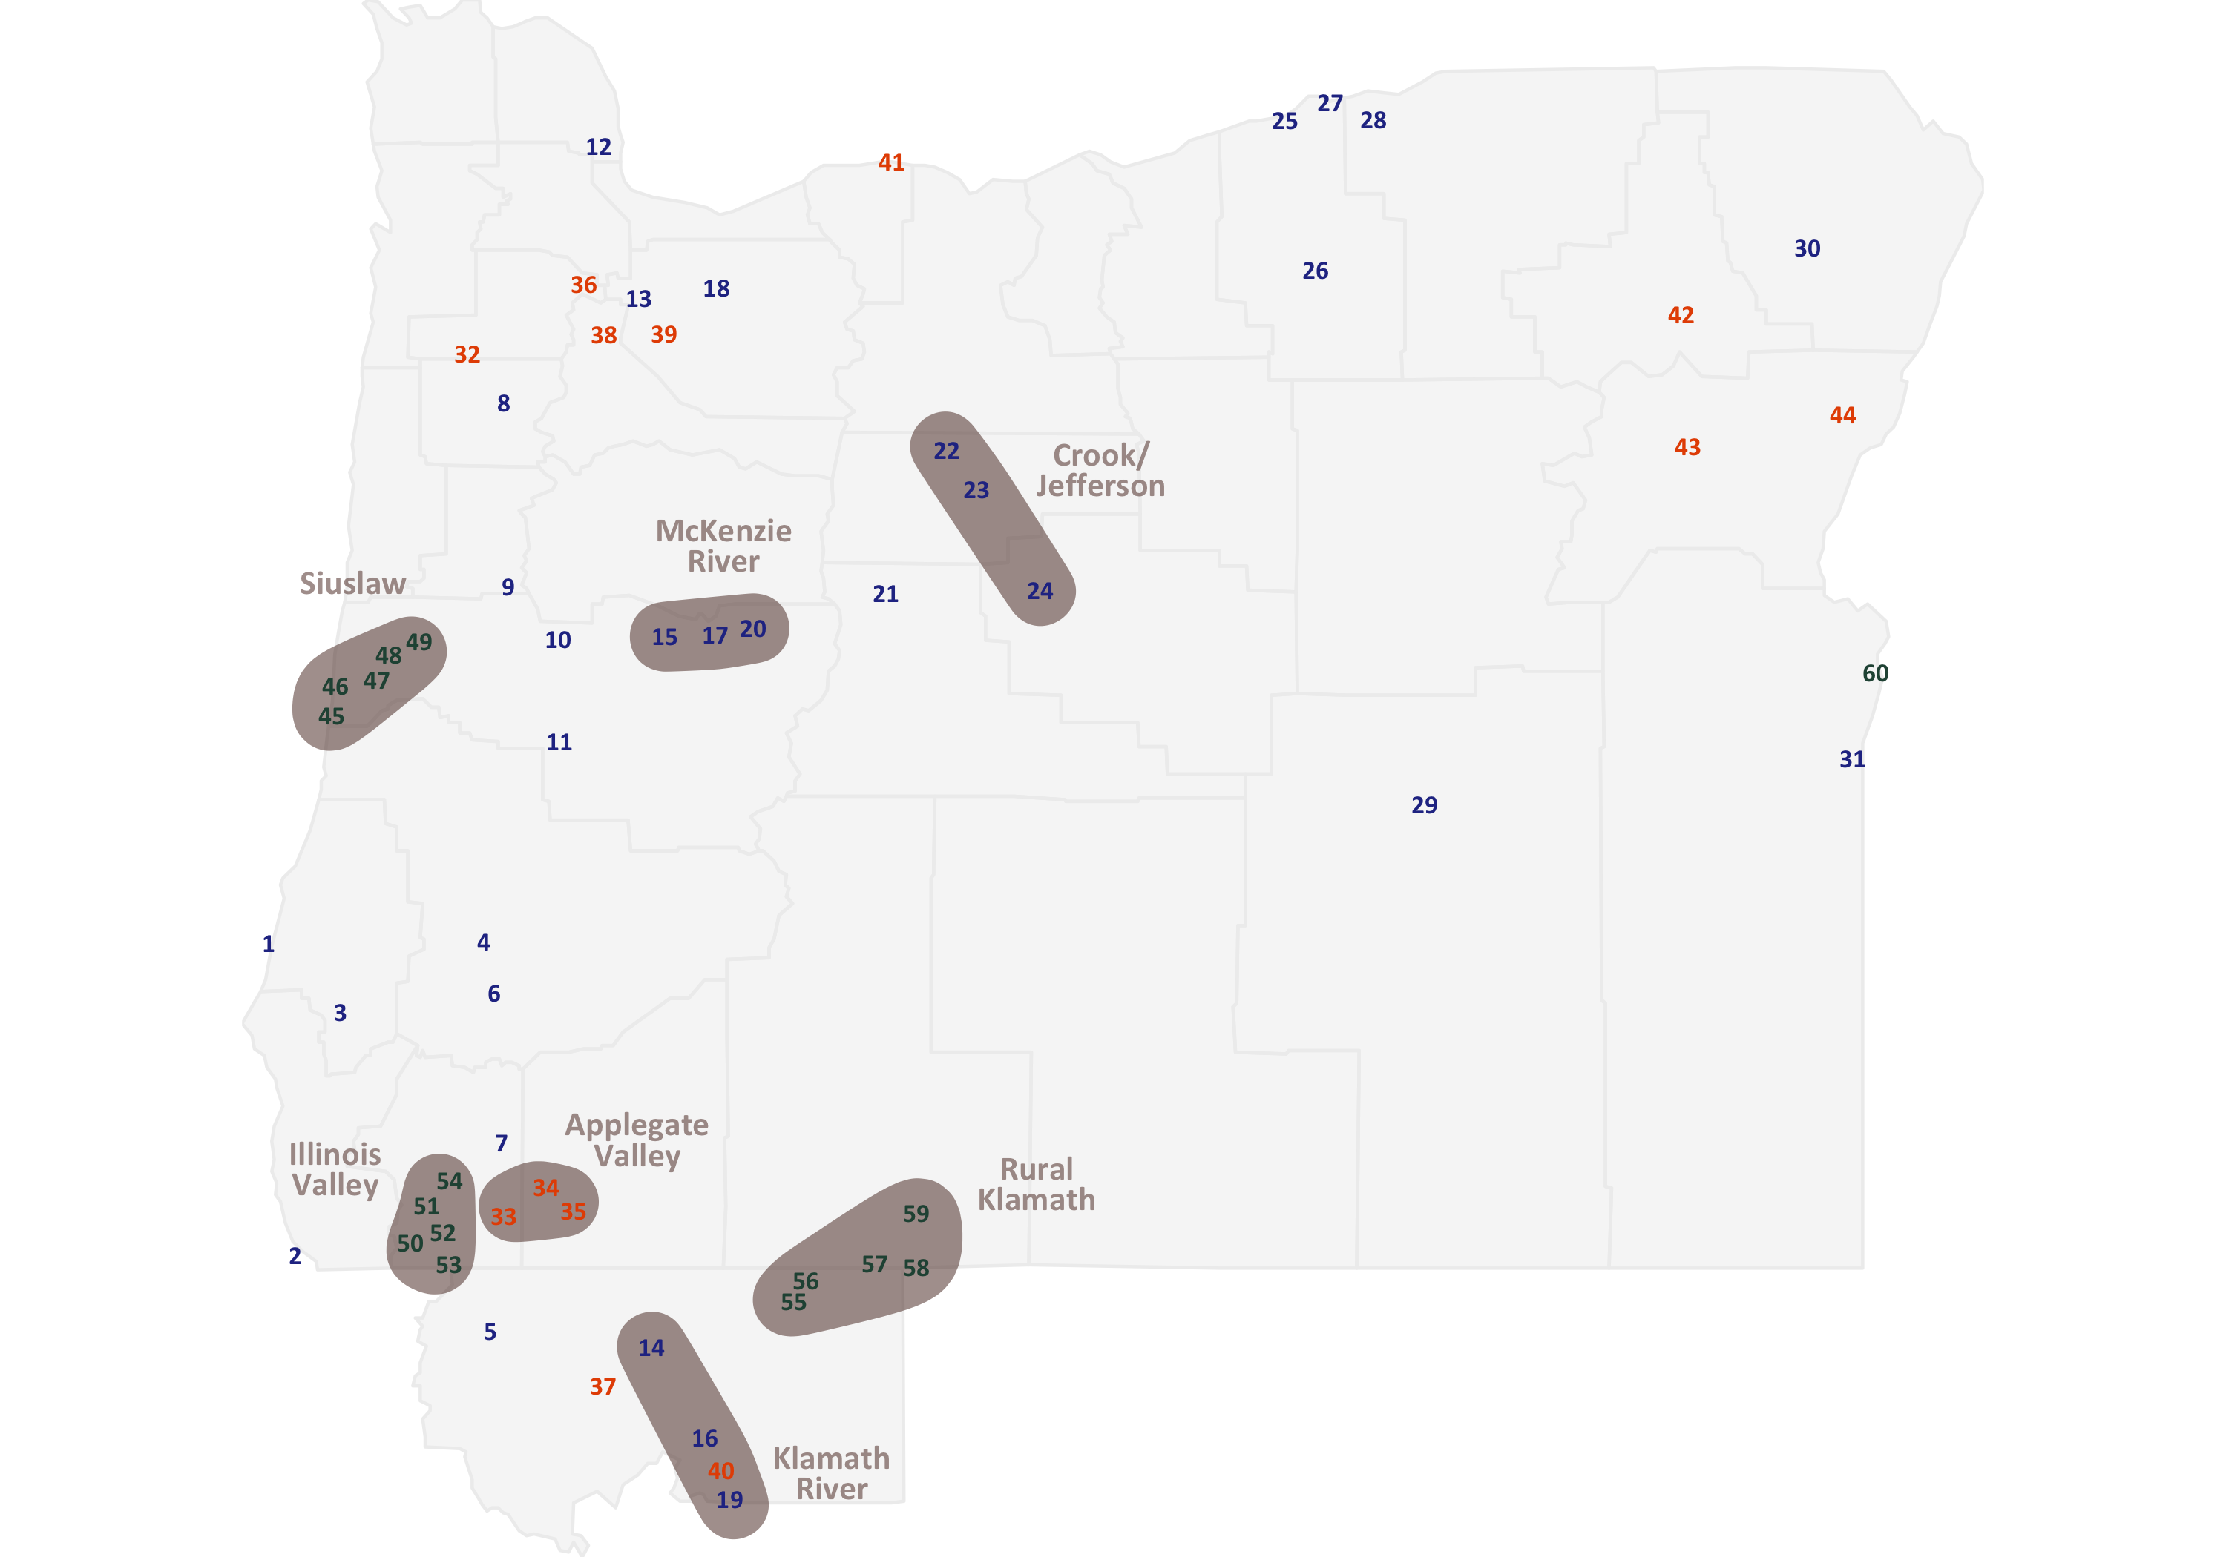

|  |  |  |  |  |  |  |  |  |  |  |  |  |  |  |  |  |  |  |  |  |  |  |  |  |  |  |  |  |  |  |  |  |  |  |  |  |  |  |  |  |  |  |  |  |  |  |  |  |  |  |  |  |  |  |  |  |  |  |  |  |  |  |  |  |  |  |  |  |  |  |  |  |  |  |  |  |  |  |  |  |  |  |  |  |  |  |  |  |  |  |  |  |  |  |  |  |  |  |  |  |  |  |  |  |  |  |  |  |  |  |  |  |  |  |  |  |  |  |  |  |  |  |  |  |  |  |  |  |  |  |  |  |  |  |  |  |  |  |  |  |  |  |  |  |  |  |  |  |  |  |  |  |  |  |  |  |  |  |  |  |  |  |  |  |  |  |  |  |  |  |  |  |  |  |  |  |  |  |  |  |  |  |  |
| --- | --- | --- | --- | --- | --- | --- | --- | --- | --- | --- | --- | --- | --- | --- | --- | --- | --- | --- | --- | --- | --- | --- | --- | --- | --- | --- | --- | --- | --- | --- | --- | --- | --- | --- | --- | --- | --- | --- | --- | --- | --- | --- | --- | --- | --- | --- | --- | --- | --- | --- | --- | --- | --- | --- | --- | --- | --- | --- | --- | --- | --- | --- | --- | --- | --- | --- | --- | --- | --- | --- | --- | --- | --- | --- | --- | --- | --- | --- | --- | --- | --- | --- | --- | --- | --- | --- | --- | --- | --- | --- | --- | --- | --- | --- | --- | --- | --- | --- | --- | --- | --- | --- | --- | --- | --- | --- | --- | --- | --- | --- | --- | --- | --- | --- | --- | --- | --- | --- | --- | --- | --- | --- | --- | --- | --- | --- | --- | --- | --- | --- | --- | --- | --- | --- | --- | --- | --- | --- | --- | --- | --- | --- | --- | --- | --- | --- | --- | --- | --- | --- | --- | --- | --- | --- | --- | --- | --- | --- | --- | --- | --- | --- | --- | --- | --- | --- | --- | --- | --- | --- | --- | --- | --- | --- | --- | --- | --- | --- | --- | --- | --- | --- | --- |
| **Level One: Developing**   |  |  |  | | --- | --- | --- | | 1 | Bandon | CN L LL LM RM PD V | | 2 | Brookings | CN L LL LM RM PD V | | 3 | Powers | CN L LL LM RM PD V | | 4 | Winston | CN L LL LM RM PD V | | 5 | Happy Camp | CN L LL LM RM PD V | | 6 | Riddle | CN L LL LM RM PD V | | 7 | Grants Pass | CN L LL LM RM PD V | | 8 | Dallas | CN L LL LM RM PD V | | 9 | Monroe | CN L LL LM RM PD V | | 10 | Coburg | CN L LL LM RM PD V | | 11 | Cottage Grove | CN L LL LM RM PD V | | 12 | Scappoose | CN L LL LM RM PD V | | 13 | Canby | CN L LL LM RM PD V | | 14 | Yreka | CN L LL LM RM PD V | | 15 | Vida | CN L LL LM RM PD V | | 16 | Weed | CN L LL LM RM PD V | | |  |  |  | | --- | --- | --- | | 17 | Blue River | CN L LL LM RM PD V | | 18 | Estacada | CN L LL LM RM PD V | | 19 | Dunsmuir | CN L LL LM RM PD V | | 20 | McKenzie Bridge | CN L LL LM RM PD V | | 21 | Sisters | CN L LL LM RM PD V | | 22 | Warm Springs | CN L LL LM RM PD V | | 23 | Madras | CN L LL LM RM PD V | | 24 | Prineville | CN L LL LM RM PD V | | 25 | Boardman | CN L LL LM RM PD V | | 26 | Heppner | CN L LL LM RM PD V | | 27 | Irrigon | CN L LL LM RM PD V | | 28 | Hermiston | CN L LL LM RM PD V | | 29 | Burns | CN L LL LM RM PD V | | 30 | Enterprise | CN L LL LM RM PD V | | 31 | Adrian | CN L LL LM RM PD V | | **Level Two: Defined**   |  |  |  | | --- | --- | --- | | 32 | Willamina | CN L LL LM RM PD V | | 33 | Williams | CN L LL LM RM PD V | | 34 | Applegate | CN L LL LM RM PD V | | 35 | Ruch | CN L LL LM RM PD V | | 36 | Newberg | CN L LL LM RM PD V | | 37 | Scott Valley | CN L LL LM RM PD V | | 38 | Woodburn | CN L LL LM RM PD V | | 39 | Molalla | CN L LL LM RM PD V | | 40 | Mt. Shasta | CN L LL LM RM PD V | | 41 | Hood River | CN L LL LM RM PD V | | 42 | Union | CN L LL LM RM PD V | | 43 | Baker City | CN L LL LM RM PD V | | 44 | Halfway | CN L LL LM RM PD V | | **Level Three: Deepening**   |  |  |  | | --- | --- | --- | | 45 | Dunes City | CN L LL LM RM PD V | | 46 | Florence | CN L LL LM RM PD V | | 47 | Mapleton | CN L LL LM RM PD V | | 48 | Swisshome | CN L LL LM RM PD V | | 49 | Deadwood | CN L LL LM RM PD V | | 50 | O'Brien | CN L LL LM RM PD V | | 51 | Kerby | CN L LL LM RM PD V | | 52 | Cave Junction | CN L LL LM RM PD V | | 53 | Takilma | CN L LL LM RM PD V | | 54 | Selma | CN L LL LM RM PD V | | 55 | Butte Valley | CN L LL LM RM PD V | | 56 | Dorris | CN L LL LM RM PD V | | 57 | Merrill | CN L LL LM RM PD V | | 58 | Malin | CN L LL LM RM PD V | | 59 | Bonanza | CN L LL LM RM PD V | | 60 | Ontario | CN L LL LM RM PD V | |

**Types of Work**

|  |  |  |  |  |  |  |
| --- | --- | --- | --- | --- | --- | --- |
| CN = Community Networking | L = Listening | LL = Latino Leadership | LM = Local Mobilizing | RM = Regional Mobilizing | PD = Project Development | V = Visioning |

|  |  |  |  |  |  |  |  |  |  |  |
| --- | --- | --- | --- | --- | --- | --- | --- | --- | --- | --- |
| **Level 1 – Developing**  Energy and potential here, with work, relationships, roles and CBA alignment coming into focus. FICB commits to engage for 3-6 months with investments < $25K.   |  |  |  | | --- | --- | --- | | 1) Warm Springs  2) Madras  3) Prineville  4) McKenzie Bridge  5) Blue River  6) Vida  7) Irrigon  8) Hermiston  9) Boardman  10) Scappoose  11) Enterprise | 12) Heppner  13) Estacada  14) Canby  15) Woodburn  16) Dallas  17) Halfway  18) Monroe  19) Sisters  20) Coburg  21) Cottage Grove  22) Adrian | 23) Burns  24) Winston  25) Bandon  26) Riddle  27) Powers  28) Grants Pass  29) Brookings  30) Happy Camp  31) Yreka  32) Weed  33) Dunsmuir |   **Level 2 - Defined**  Work and roles are well defined, with solid CBA alignment and relationships FICB commits to engage for 6-18 months with investments ranging from $10K-$75K   |  |  |  | | --- | --- | --- | | 34) Applegate  35) Ruch  36) Williams  37) Hood River | 38) Newberg  39) Union  40) Molalla  41) Willamina | 42) Baker City  43) Scott Valley  44) Mt. Shasta |   **Level 3 - Deepening**  Successful work and sufficient capacity allows for expanding efforts and new innovations with powerful CBA alignment and a greater emphasis on learning and impact. FICB commits engage 1-3+ years with investments ranging from $50K to $300K).   |  |  |  | | --- | --- | --- | | 45) Selma  46) Kerby  47) Cave Junction  48) O'Brien  49) Takilma  50) Bonanza | 51) Merrill  52) Malin  53) Dorris  54) Butte Valley  55) Deadwood | 56) Swisshome  57) Mapleton  58) Florence  59) Dunes City  60) Ontario | | **FICB Work Map**  The size and color of each point show the level of engagement (see left). Regions where work is happening are shown circled. |

|  |  |  |  |  |  |  |  |  |  |  |  |
| --- | --- | --- | --- | --- | --- | --- | --- | --- | --- | --- | --- |
| **FICB Work Map**  The size and color of each point show the level of engagement (see right). Regions where work is happening are circled. | |  |  |  |  |  |  |  |  |  |  | | --- | --- | --- | --- | --- | --- | --- | --- | --- | --- | | **Level 1 – Developing**  Energy and potential here, with work, relationships, roles and CBA alignment coming into focus. FICB commits to engage for 3-6 months with investments < $25K.   |  |  |  | | --- | --- | --- | | 1) Warm Springs  2) Madras  3) Prineville  4) McKenzie Bridge  5) Blue River  6) Vida  7) Irrigon  8) Hermiston  9) Boardman  10) Scappoose  11) Enterprise | 12) Heppner  13) Estacada  14) Canby  15) Woodburn  16) Dallas  17) Halfway  18) Monroe  19) Sisters  20) Coburg  21) Cottage Grove  22) Adrian | 23) Burns  24) Winston  25) Bandon  26) Riddle  27) Powers  28) Grants Pass  29) Brookings  30) Happy Camp  31) Yreka  32) Weed  33) Dunsmuir |   **Level 2 - Defined**  Work and roles are well defined, with solid CBA alignment and relationships FICB commits to engage for 6-18 months with investments ranging from $10K-$75K   |  |  |  | | --- | --- | --- | | 34) Applegate  35) Ruch  36) Williams  37) Hood River | 38) Newberg  39) Union  40) Molalla  41) Willamina | 42) Baker City  43) Scott Valley  44) Mt. Shasta |   **Level 3 - Deepening**  Successful work and sufficient capacity allows for expanding efforts and new innovations with powerful CBA alignment and a greater emphasis on learning and impact. FICB commits engage 1-3+ years with investments ranging from $50K to $300K).   |  |  |  | | --- | --- | --- | | 45) Selma  46) Kerby  47) Cave Junction  48) O'Brien  49) Takilma  50) Bonanza | 51) Merrill  52) Malin  53) Dorris  54) Butte Valley  55) Deadwood | 56) Swisshome  57) Mapleton  58) Florence  59) Dunes City  60) Ontario | | |

|  |  |  |  |  |
| --- | --- | --- | --- | --- |
| **Counties where FICB Work is Happening**  The dots show where each field coordinator is based.    **Field Coordinators**   |  |  |  | | --- | --- | --- | | 1) Maurizio Valerio (Medical Springs)  2) Crystal Aston (Mt Shasta) | 3) Denise Bacon (Newberg)  4) Laura Isiordia (Woodburn) | 5) Max Gimbel (Roseburg)  6) Roque Barrios (Roseburg) | | **Counties where Each Field Coordinator Works** |